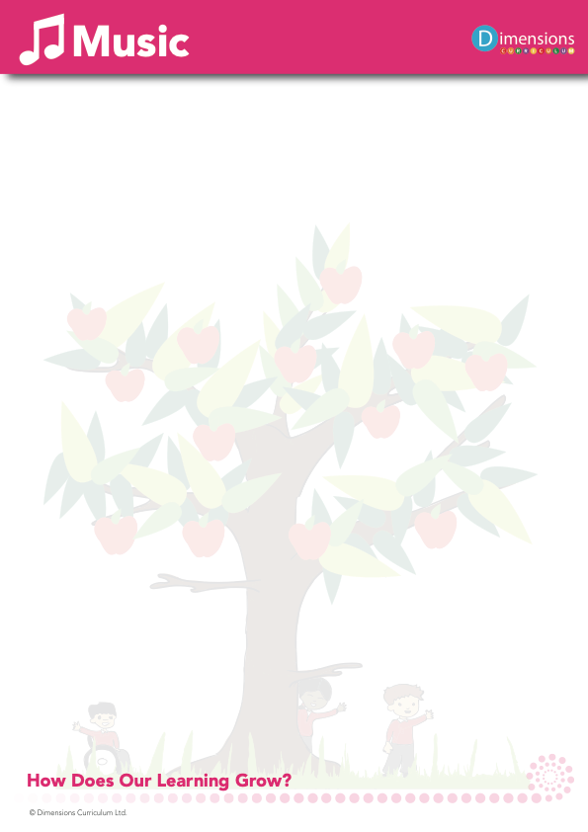

Why is Music important?
Through music, we are provided with a powerful universal language which helps promote unity, enables us to process and express our emotions and fuels our imagination.

Music is important in developing individual discipline, focus and memory.

Whether the we are singing, playing, or listening, we develop our aural discrimination through music, which is an important part of communication and literacy.

When is Music taught?
Music is taught through thematic units. The attached overview (Appendix 1) maps out which thematic units feature this subject and the Long-Term Plan (Appendix 2) clearly shows the objectives taught.

How is Music taught?
Music is taught through a combination of subject knowledge and composing, performing, listening and appraising skills. Learning takes place both inside and outside the classroom.

Who do we learn about in Music?
We learn about a range of famous composers from history, such as J.S. Bach, Ludwig Van Beethoven and Rimsky-Korsakov.
We also learn about more contemporary composers, such as Andrew Lloyd-Webber.

What do we learn about in Music?
We learn about the following:-

Notation
Graphic scores
Signs and symbols
Soundscapes
Sound effects

Singing
Sea shanties
Folk songs
National anthems
Slave songs

Battle chants
War songs
Cyclic patterns
Instrument families
Evolution of instruments
African music, including drumming
Celtic music
Hannukah music
Jingles
Film music
Musicals
Inuit throat singing

How do we assess and monitor Music?

Teachers assess pupils’ skills and knowledge in Music using both formative and summative assessment. At the end of each thematic unit, children are assessed in Music as working towards year group expectations (W), meeting year group expectations (E), or exceeding year group expectations (X). Teachers use subject specific criteria from the National Curriculum Programmes of Study to assess pupils’ knowledge, skills and understanding within Music.
Summative Assessment data is updated termly and made available to the Music Subject Leader at regular points throughout the year. The Subject Leader uses this to monitor attainment and progress in Music for the whole school.
Subject leaders monitor their subject throughout the year using a range of evidence including pupil and teacher voice, learning walks, learning environments and book scrutiny. Subject leaders also complete a ‘Deep Dive’ into their subject each year, to monitor pupil progress, and teaching and learning within Music.

